Store Clark

View Stationery Catalogue

Click “View Stationery Catalogue” link from menu to view stationery catalogue screen.

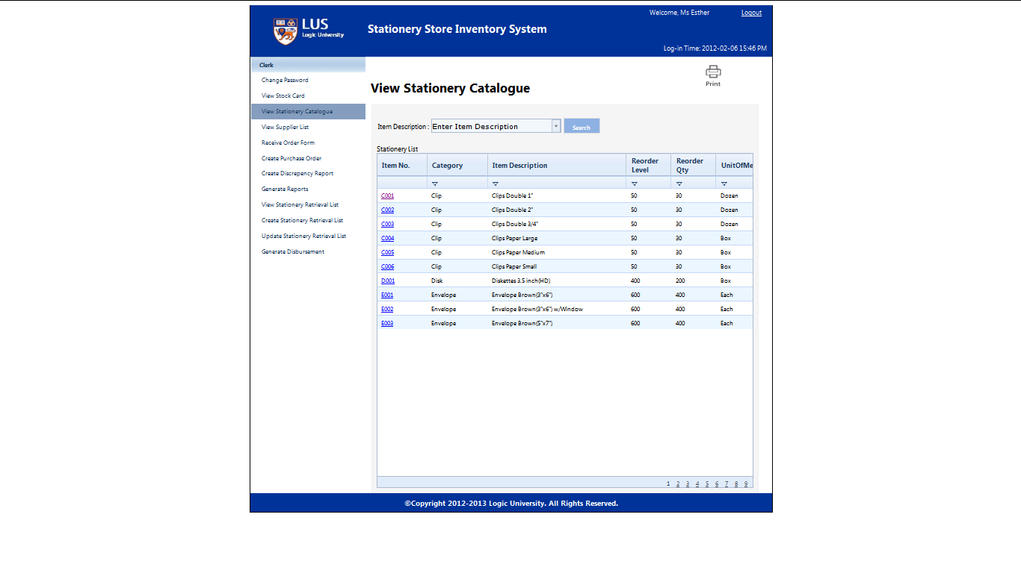

Enter Item Description keyword and click “Search”

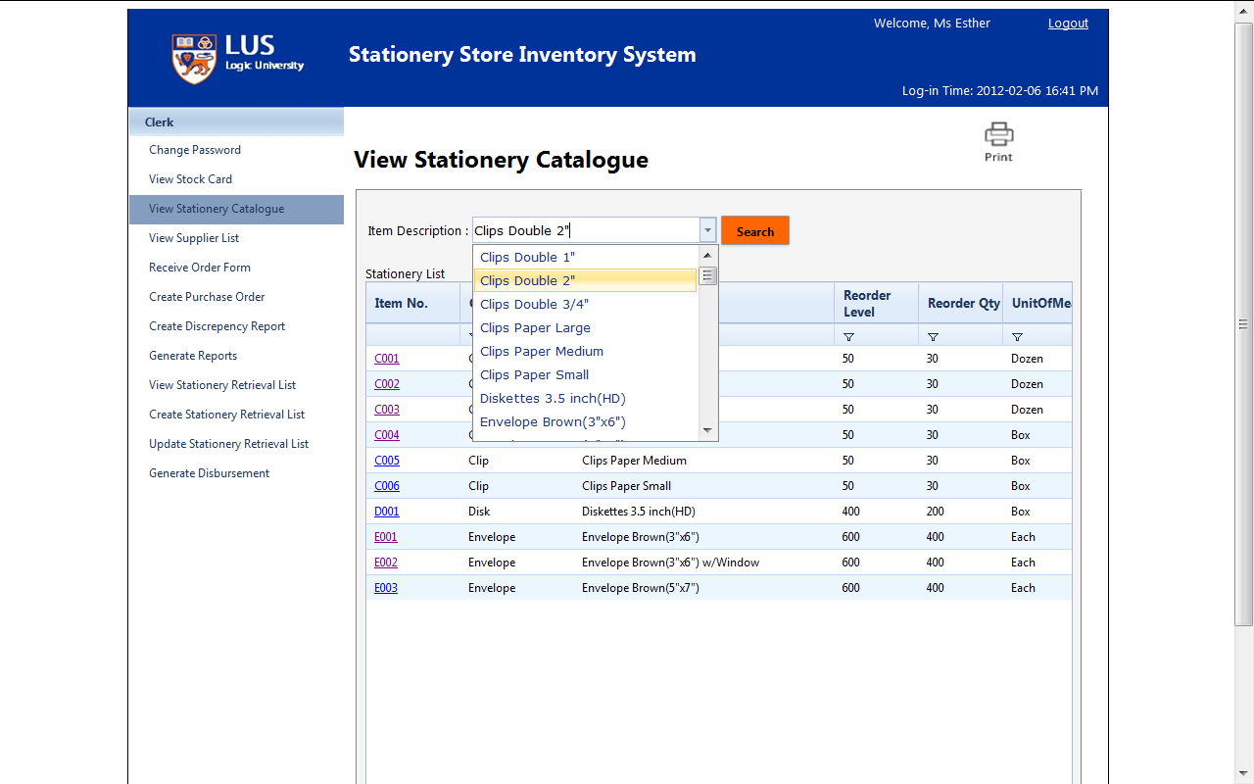

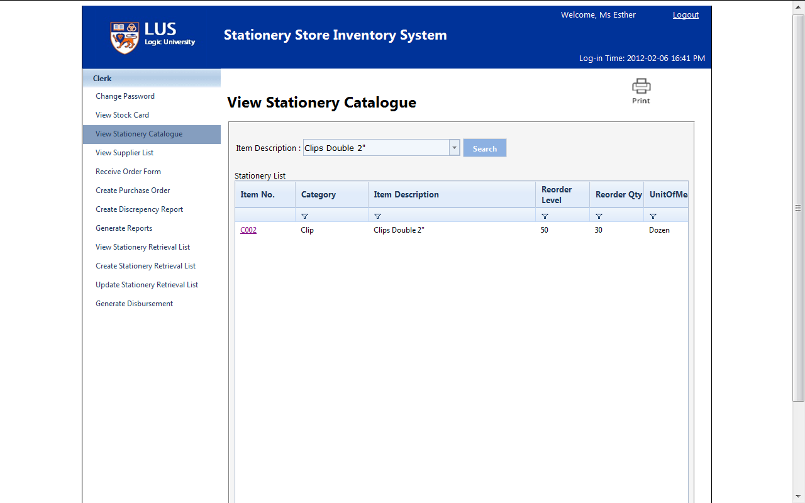

Click Item No. link to view the selected item in stock card

